Welcome to
Grace Lutheran Church
6/8/25
Pentecost



growing in faith,
serving in love,
proclaiming God’s grace!

200 Wabash Avenue Ukiah, CA 95482
Office (707) 462-7795 gracelutheranukiah@gmail.com
www.gracelutheranukiah.com

Pastor Kristi Gallimore

Information for your first time at Grace…

THANK YOU for worshipping with us this day. We hope you experience the presence of God in this place and you are encouraged to further your personal relationship with Jesus Christ. If you’re looking for a community of believers to worship God with, we would like you to consider us your new church home. WELCOME!!

HOLY COMMUNION: is offered to all that hunger for the presence and promises of the risen Christ. We welcome all to the Lord’s Table at our service.

RESTROOMS: are conveniently located in the fellowship hall and in the sanctuary hall.

OUR WORSHIP TODAY

MINISTERS: All Members of the Congregation

WORSHIP LEADER: Pastor Kristi Gallimore

MUSICIAN: Lori Schafer and Galen Gallimore

AUDIO VISUAL: Jack Vinyard, Nathaniel Gallimore,
Kristopher Sullivan, Layla Mason

ASISSTANT/PRAYER:

READER: Cheryl Johnson

USHER: Glen Steliga & Tom Koppa

CUSTODIAN: Gwen & Lynn

Gathering

L=Leader A=Assistant R=Reader C=Congregation

Welcome To Grace Lutheran Chruch
CONFESSION AND FORGIVENESS (Please Stand)

P: Let us confess our sin in the presence of God and of one another.
[Silence is kept for reflection.]

C: We serve a risen Savior yet live as if in chains.
Forgive us as we hesitate to live the resurrection life.
Forgive us when we fail to share your love.
Forgive us as fear prevents us from living our full potential.
Draw us close.
Open our eyes to the glory of the risen Christ,
Open our hands to the service of your kingdom.

P: God of resurrection
of life and death
and rebirth
C: Renew our hearts and minds

P: God of all beginnings
and all endings
C: Renew our hearts and minds
P: God of hope
of new growth
and harvest
C: Renew our hearts and minds

P: You belong to Christ Jesus and you are God’s children through
faith. In the cross of ☩ Christ, and through the power of the Holy
Spirit, your sins are forgiven. Clothed with Christ, you are a new
creation. All: Amen.

Sharing the Peace Of GOD
[Please greet one another with a sign of Christ's peace with a hand gesture or wave.]

P: The grace of our Lord Jesus Christ, the love of God,
and the communion of the Holy Spirit be with you all.
C: And also with you.
P: The peace of the Lord be with you always.
C: And also with you.

Spirit of Gentleness ELW #396
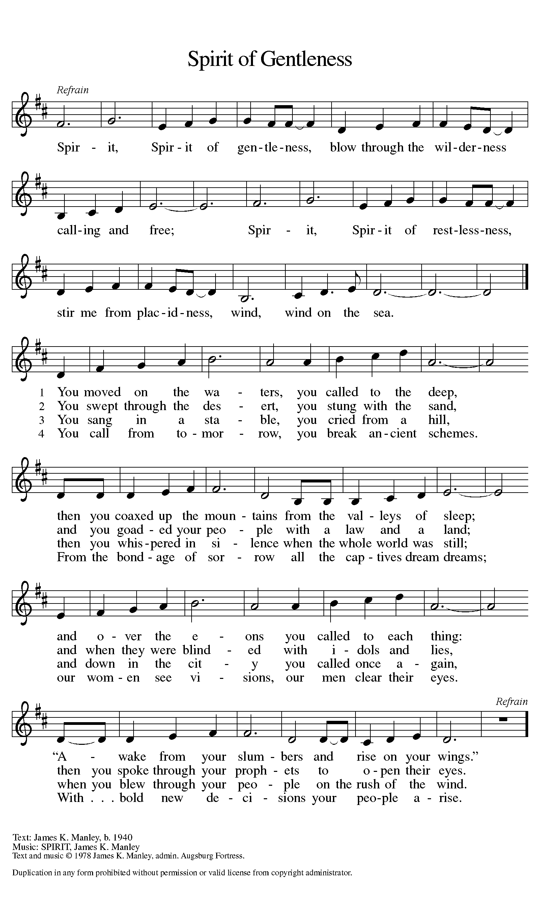

PRAYER OF THE DAY
P: Let us pray together.
C: Gracious God, bring you people together to live your great
mission. Send your Spirit to empower us to live as Jesus lived.
C: Amen
(The assembly is seated)
The Word of God

First Reading: Before Jesus ascended into heaven, he told his disciples

they would be filled with the Holy Spirit. Now, amid signs of fire, wind,

and a variety of languages, the people were amazed and astonished at

Jesus’ promise coming true.

Acts 2:1-21
¹ When the day of Pentecost had come, [the apostles] were all together in one place. ² And suddenly from heaven there came a sound like the rush of a violent wind, and it filled the entire house where they were sitting. ³ Divided tongues, as of fire, appeared among them, and a tongue rested on each of them. ⁴ All of them were filled with the Holy Spirit and began to speak in other languages, as the Spirit gave them ability.
⁵ Now there were devout Jews from every nation under heaven living in Jerusalem. ⁶ And at this sound the crowd gathered and was bewildered, because each one heard them speaking in the native language of each. ⁷ Amazed and astonished, they asked, “Are not all these who are speaking Galileans? ⁸ And how is it that we hear, each of us, in our own native language? ⁹ Parthians, Medes, Elamites, and residents of Mesopotamia, Judea and Cappadocia, Pontus and Asia, ¹⁰ Phrygia and Pamphylia, Egypt and the parts of Libya belonging to Cyrene, and visitors from Rome, both Jews and proselytes, ¹¹ Cretans and Arabs—in our own languages we hear them speaking about God’s deeds of power.” ¹² All were amazed and perplexed, saying to one another, “What does this mean?” ¹³ But others sneered and said, “They are filled with new wine.”
¹⁴ But Peter, standing with the eleven, raised his voice and addressed them, “Men of Judea and all who live in Jerusalem, let this be known to you, and listen to what I say. ¹⁵ Indeed, these are not drunk, as you suppose, for it is only nine o’clock in the morning. ¹⁶ No, this is what was spoken through the prophet Joel:
¹⁷ ‘In the last days it will be, God declares,
that I will pour out my Spirit upon all flesh,
and your sons and your daughters shall prophesy,
and your young men shall see visions,
and your old men shall dream dreams.
¹⁸ Even upon my slaves, both men and women,
in those days I will pour out my Spirit;
and they shall prophesy.
¹⁹ And I will show portents in the heaven above
and signs on the earth below,
blood, and fire, and smoky mist.
²⁰ The sun shall be turned to darkness
and the moon to blood,
before the coming of the Lord’s great and glorious day.
²¹ Then everyone who calls on the name of the Lord shall be saved.’ ”
R: The word of the Lord C: Thanks be to God

Second Reading: Here Paul speaks about the mystery of baptism: through the Holy Spirit we are claimed, gathered, and welcomed into Christ’s body, the church. And we receive a new name in our adoption: child of God.

Romans 8:14-17
¹⁴ For all who are led by the Spirit of God are children of God. ¹⁵ For you did not receive a spirit of slavery to fall back into fear, but you have received a spirit of adoption. When we cry, “Abba! Father!” ¹⁶ it is that very Spirit bearing witness with our spirit that we are children of God, ¹⁷ and if children, then heirs, heirs of God and joint heirs with Christ—if, in fact, we suffer with him so that we may also be glorified with him.
R: The word of the Lord C: Thanks be to God

Children’s Message
(Please Stand)
Gospel Reading: Though the disciples struggle with Jesus’ nature and identity, they receive the promise that they too will be identified with God and God’s mission. Though he must leave them now, Jesus promises the coming of the Advocate whom God will send to comfort and enlighten them.
John 14:8-17 [24-27]
⁸ Philip said to [Jesus,] “Lord, show us the Father, and we will be satisfied.” ⁹ Jesus said to him, “Have I been with you all this time, Philip, and you still do not know me? Whoever has seen me has seen the Father. How can you say, ‘Show us the Father’? ¹⁰ Do you not believe that I am in the Father and the Father is in me? The words that I say to you I do not speak on my own; but the Father who dwells in me does his works. ¹¹ Believe me that I am in the Father and the Father is in me; but if you do not, then believe me because of the works themselves. ¹² Very truly, I tell you, the one who believes in me will also do the works that I do and, in fact, will do greater works than these, because I am going to the Father. ¹³ I will do whatever you ask in my name, so that the Father may be glorified in the Son. ¹⁴ If in my name you ask me for anything, I will do it.
¹⁵ “If you love me, you will keep my commandments. ¹⁶ And I will ask the Father, and he will give you another Advocate, to be with you forever.
¹⁷ This is the Spirit of truth, whom the world cannot receive, because it neither sees him nor knows him. You know him, because he abides with you, and he will be in you. [
²⁵ “I have said these things to you while I am still with you. ²⁶ But the Advocate, the Holy Spirit, whom the Father will send in my name, will teach you everything, and remind you of all that I have said to you. ²⁷ Peace I leave with you; my peace I give to you. I do not give to you as the world gives. Do not let your hearts be troubled, and do not let them be afraid.”]
R: The Gospel of the Lord C: Thanks be to God
(Please be seated)
Sermon
Pastor Kristi Gallimore (Please Stand)

CREED
(A brief statement of the core beliefs of the Christian Church)

P: Let us confess our faith using the words of the Apostles’ Creed

C: I believe in God, the Father almighty,
creator of heaven and earth.
I believe in Jesus Christ, his only Son, our Lord.
He was conceived by the power of the Holy Spirit
and born of the virgin Mary.
He suffered under Pontius Pilate,
was crucified, died, and was buried. He descended into hell.

On the third day he rose again. He ascended into heaven,
and is seated at the right hand of the Father.
He will come again to judge the living and the dead.
I believe in the Holy Spirit,
the holy catholic church, the communion of saints,
the forgiveness of sins, the resurrection of the body,
and the life everlasting. C: Amen

PRayers of the people
A: God of resurrection and new life, we come before you in prayer for
the church, the world, and all who are in need.
A: Lord, in your mercy
C: hear our prayer [The prayers are concluded…]

A: We commend these and all our prayers to you, O God, trusting that
you are always with us. C: Amen
(Please be seated)


OFFERING
We offer our gifts of time, talent, food and finances to God to return to God all the
blessings He has first given us. Please put your offering in the plate as it is passed.

Spirit of the Living God Words & Music by
Daniel Iverson

CCLI Song # 23488 © Words: 1935. Renewed 1963 Birdwing Music | Music: 1935. Renewed 1963 Birdwing Music For use solely with the SongSelect® Terms of Use. All rights reserved. www.ccli.com CCLI License # 1124257

P: Risen One,
you have gathered us around your table of grace
along with these gifts we bring.
Come among us again,
breathe your life into us,
and enliven us with this meal,
that we may live as your risen body in the world. C: Amen
The mEal

Christ is truly present in the bread and the wine. This makes communion one of the places where God’s touch can be most clearly felt. [Grape juice and gluten-free wafers are available upon request.]

P: God of all creation, all you have made is good,
C: and your love endures forever.
P: You bring forth bread from the earth
C: and fruit from the vine.
P: Nourish us with these gifts,
All: that we might be for the world signs of your gracious presence.
C: Amen
P: In the night in which he was betrayed, our Lord Jesus took bread,
and gave thanks; broke it, and gave it to his disciples, saying: Take and eat;
this is my body, given for you. Do this for the remembrance of me.
Again, after supper, he took the cup, gave thanks, and gave it for all to
drink, saying: This cup is the new covenant in my blood, shed for you and
for all people for the forgiveness of sin. Do this for the remembrance of me.

For as often as we eat of this bread and drink from this cup,
we proclaim the Lord’s death until he comes.
C: Christ has died. Christ is risen. Christ will come again

P: Let us pray the prayer that our Lord first gave us.
C: Our Father, who art in heaven, hallowed be thy name,
thy kingdom come, thy will be done,
on earth as it is in heaven.
Give us this day our daily bread;
and forgive us our trespasses,
as we forgive those who trespass against us;
and lead us not into temptation, but deliver us from evil.
For thine is the kingdom,
and the power, and the glory, forever and ever. C: Amen
P: Come for all is ready. (The ushers will call up you up)
Communion Distribution

P: The body and blood of our Lord Jesus Christ strengthen you
and keep you in his grace. C: Amen

P: Living One,
in this feast you have made yourself known to us.
Send us now to tell of your wonders, sing of your glory,
and proclaim your risen life to a wounded and weary world. C: Amen

SENDING

BLESSING (Please Stand)
The triune God,
who was, who is, and who is to come,
Sovereign, ☩ Savior, and Spirit,
light your way with resurrection dawn,
now and always.
C: Amen. [The assembly is seated.]

BRIEF ANNOUNCEMENTS & WEEKLY REFLECTION

Every Time I Feel the Spirit ACS #942
(Please Stand)
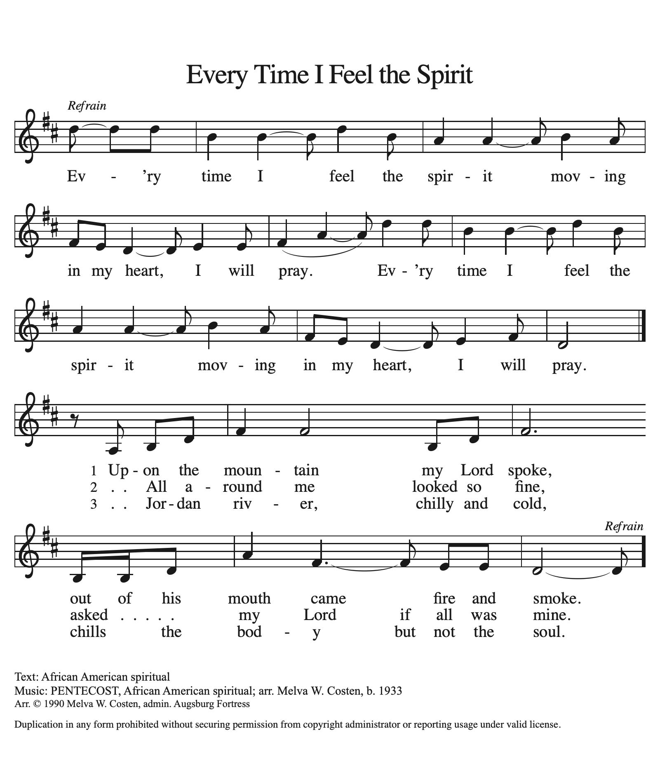

DISMISSAL
P: Alleluia! Christ is risen.
C: Christ is risen indeed. Alleluia!
P: Go in peace. In Christ you are made new. Alleluia! Alleluia!
C: Thanks be to God. Alleluia! Alleluia!
POSTLUDE

