Welcome to
Grace Lutheran Church
5/18/25


growing in faith,
serving in love,
proclaiming God’s grace!

200 Wabash Avenue Ukiah, CA 95482
Office (707) 462-7795 gracelutheranukiah@gmail.com
www.gracelutheranukiah.com

Pastor Kristi Gallimore

Information for your first time at Grace…

THANK YOU for worshipping with us this day. We hope you experience the presence of God in this place and you are encouraged to further your personal relationship with Jesus Christ. If you’re looking for a community of believers to worship God with, we would like you to consider us your new church home. WELCOME!!

HOLY COMMUNION: is offered to all that hunger for the presence and promises of the risen Christ. We welcome all to the Lord’s Table at our service.

RESTROOMS: are conveniently located in the fellowship hall and in the sanctuary hall.

OUR WORSHIP TODAY

MINISTERS: All Members of the Congregation

WORSHIP LEADER: Pastor Kristi Gallimore

MUSICIAN: Lori Schafer and Galen Gallimore

AUDIO VISUAL: Jack Vinyard, Nathaniel Gallimore,
Kristopher Sullivan, Layla Mason

ASISSTANT/PRAYER:

READER: Anne Barnes

USHER: Bill Yoder & Kristopher Sullivan

CUSTODIAN: SDA Church

Gathering

L=Leader A=Assistant R=Reader C=Congregation

Welcome To Grace Lutheran Chruch
CONFESSION AND FORGIVENESS (Please Stand)

P: Let us confess our sin in the presence of God and of one another.
[Silence is kept for reflection.]

C: We serve a risen Savior yet live as if in chains.
Forgive us as we hesitate to live the resurrection life.
Forgive us when we fail to share your love.
Forgive us as fear prevents us from living our full potential.
Draw us close.
Open our eyes to the glory of the risen Christ,
Open our hands to the service of your kingdom.

P: God of resurrection
of life and death
and rebirth
C: Renew our hearts and minds

P: God of all beginnings
and all endings
C: Renew our hearts and minds
P: God of hope
of new growth
and harvest
C: Renew our hearts and minds All: Amen.

Sharing the Peace Of GOD
[Please greet one another with a sign of Christ's peace with a hand gesture or wave.]

P: The grace of our Lord Jesus Christ, the love of God,
and the communion of the Holy Spirit be with you all.
C: And also with you.
P: The peace of the Lord be with you always.
C: And also with you.

Now the Green Blade Rises ELW #379
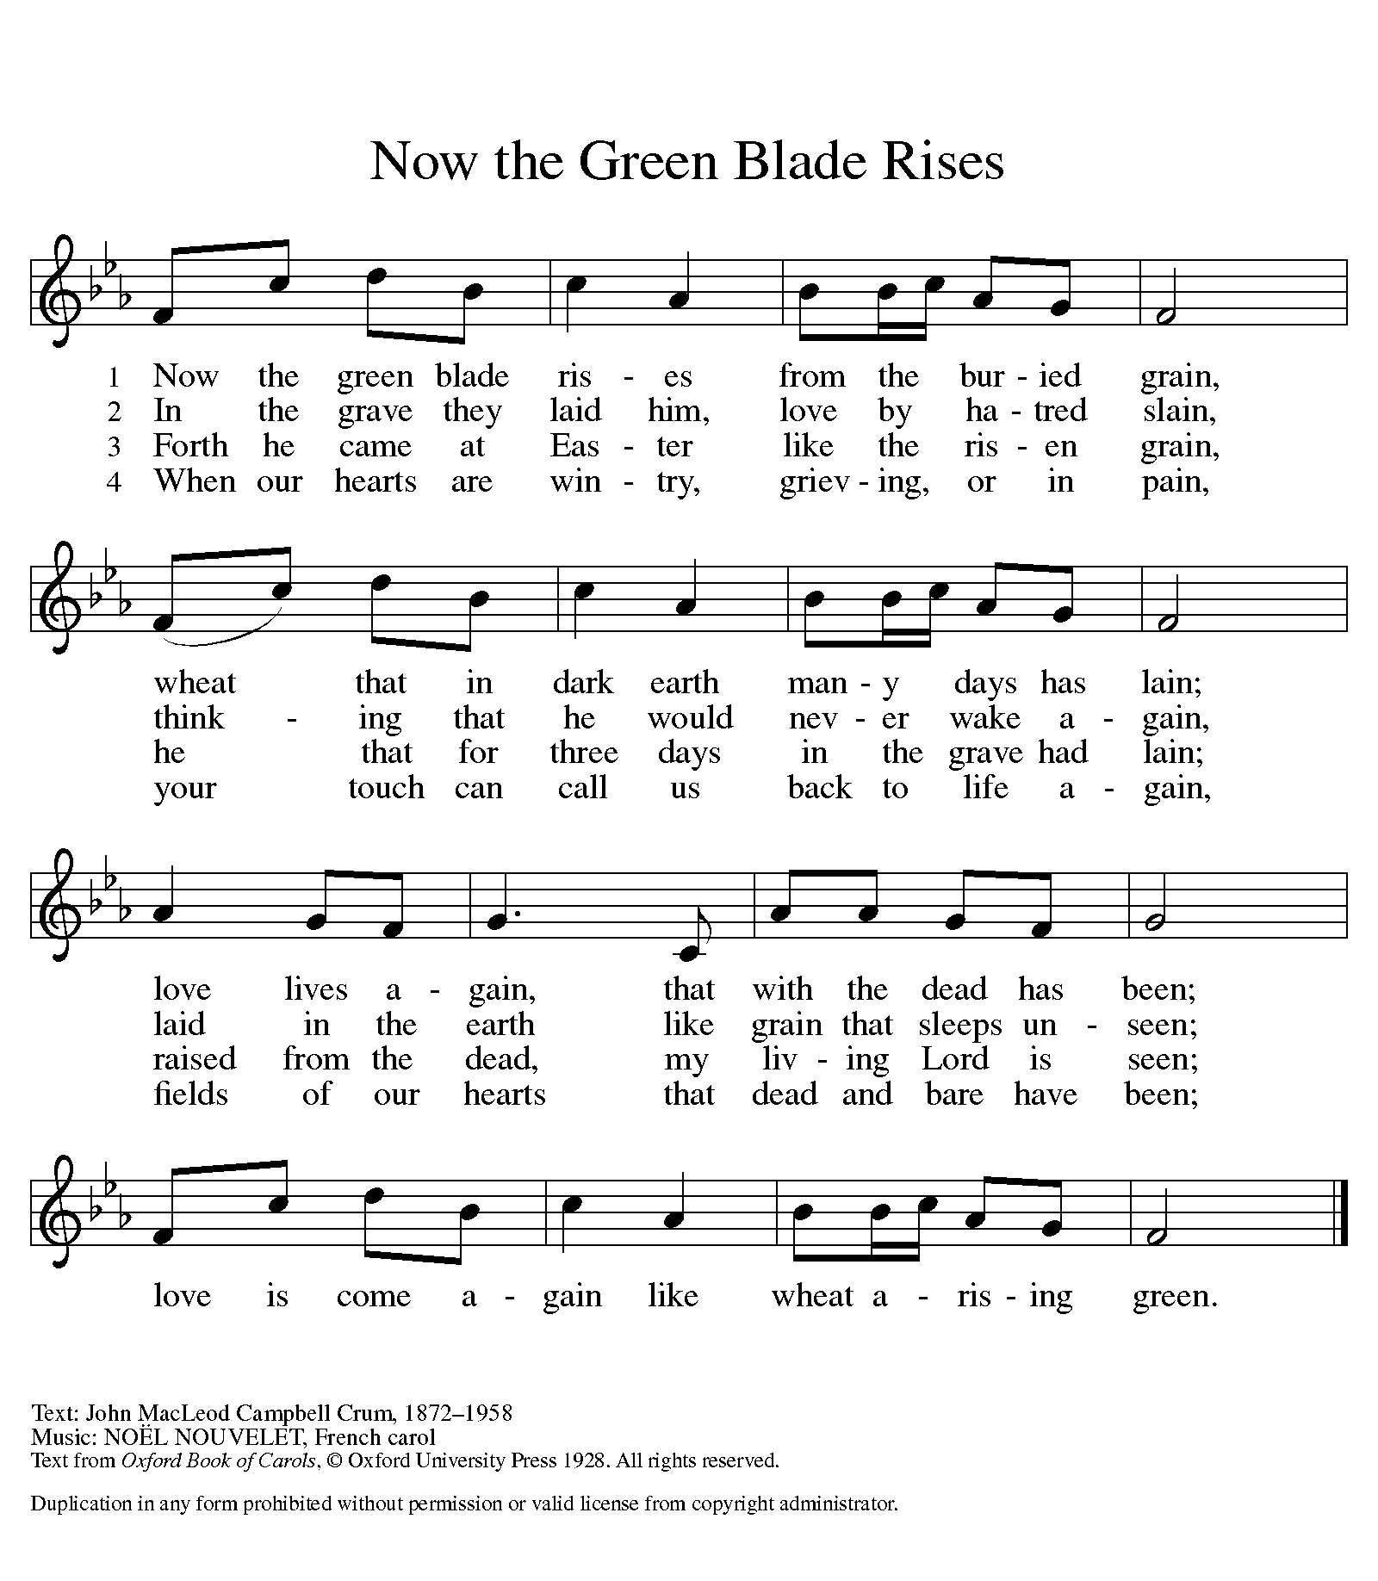

PRAYER OF THE DAY
P: Let us pray together.
C: O Lord God, you teach us that without love, our actions gain
nothing. Pour into our hearts your most excellent gift of love, that,
made alive by your Spirit, we may know goodness and peace.
C: Amen
(The assembly is seated)
The Word of God

First Reading: In defense of his earlier baptism of non-Jewish believers,

Peter demonstrates to the members of the Jerusalem church that God’s

intention to love Gentiles as well as Jews is revealed in Jesus’ testimony.

In this way the mission to the Gentiles is officially authorized.

Acts 11:1-18
¹ Now the apostles and the believers who were in Judea heard that the Gentiles had also accepted the word of God. ² So when Peter went up to Jerusalem, the circumcised believers criticized him, ³ saying, “Why did you go to uncircumcised men and eat with them?” ⁴ Then Peter began to explain it to them, step by step, saying, ⁵ “I was in the city of Joppa praying, and in a trance I saw a vision. There was something like a large sheet coming down from heaven, being lowered by its four corners; and it came close to me. ⁶ As I looked at it closely I saw four-footed animals, beasts of prey, reptiles, and birds of the air. ⁷ I also heard a voice saying to me, ‘Get up, Peter; kill and eat.’ ⁸ But I replied, ‘By no means, Lord; for nothing profane or unclean has ever entered my mouth.’ ⁹ But a second time the voice answered from heaven, ‘What God has made clean, you must not call profane.’ ¹⁰ This happened three times; then everything was pulled up again to heaven. ¹¹ At that very moment three men, sent to me from Caesarea, arrived at the house where we were. ¹² The Spirit told me to go with them and not to make a distinction between them and us. These six brothers also accompanied me, and we entered the man’s house. ¹³ He told us how he had seen the angel standing in his house and saying, ‘Send to Joppa and bring Simon, who is called Peter; ¹⁴ he will give you a message by which you and your entire household will be saved.’ ¹⁵ And as I began to speak, the Holy Spirit fell upon them just as it had upon us at the beginning. ¹⁶ And I remembered the word of the Lord, how he had said, ‘John baptized with water, but you will be baptized with the Holy Spirit.’ ¹⁷ If then God gave them the same gift that he gave us when we believed in the Lord Jesus Christ, who was I that I could hinder God?” ¹⁸ When they heard this, they were silenced. And they praised God, saying, “Then God has given even to the Gentiles the repentance that leads to life.”
R: The word of the Lord C: Thanks be to God

Second Reading: John’s vision shows us that in the resurrection the new age has dawned; God dwells with us already. Yet we wait for the time when the tears that cloud our vision will be wiped away. Then we will see the new heaven, new earth, and new Jerusalem.

Revelation 21:1-6
¹ I saw a new heaven and a new earth; for the first heaven and the first earth had passed away, and the sea was no more. ² And I saw the holy city, the new Jerusalem, coming down out of heaven from God, prepared as a bride adorned for her husband. ³ And I heard a loud voice from the throne saying,
“See, the home of God is among mortals.
He will dwell with them;
they will be his peoples,
and God himself will be with them;
⁴ he will wipe every tear from their eyes.
Death will be no more;
mourning and crying and pain will be no more,
for the first things have passed away.”
⁵ And the one who was seated on the throne said, “See, I am making all things new.” Also he said, “Write this, for these words are trustworthy and true.” ⁶ Then he said to me, “It is done! I am the Alpha and the Omega, the beginning and the end. To the thirsty I will give water as a gift from the spring of the water of life.”
R: The word of the Lord C: Thanks be to God

Children’s Message
(Please Stand)
Gospel Reading: After washing the disciples’ feet, predicting his betrayal, and then revealing his betrayer, Jesus speaks of his glorification on the cross. This deep complicated love of Jesus, even to death on the cross, will be the distinctive mark of Jesus’ community.
John 13:31-35
³¹ When he had gone out, Jesus said, “Now the Son of Man has been glorified, and God has been glorified in him. ³² If God has been glorified in him, God will also glorify him in himself and will glorify him at once. ³³ Little children, I am with you only a little longer. You will look for me; and as I said to the Jews so now I say to you, ‘Where I am going, you cannot come.’ ³⁴ I give you a new commandment, that you love one another. Just as I have loved you, you also should love one another. ³⁵ By this everyone will know that you are my disciples, if you have love for one another.”
R: The Gospel of the Lord C: Thanks be to God
(Please be seated)
Sermon
Pastor Kristi Gallimore
(Please Stand)

How Far Love Goes
CCLI Song # 7067101
Jeremy Johnson | Paul Marino
© 2016 Van Ness Press, Inc.
For use solely with the SongSelect® Terms of Use. All rights reserved. www.ccli.com

CREED
(A brief statement of the core beliefs of the Christian Church)

P: Let us confess our faith using the words of the Apostles’ Creed

C: I believe in God, the Father almighty,
creator of heaven and earth.
I believe in Jesus Christ, his only Son, our Lord.
He was conceived by the power of the Holy Spirit
and born of the virgin Mary.
He suffered under Pontius Pilate,
was crucified, died, and was buried. He descended into hell.

On the third day he rose again. He ascended into heaven,
and is seated at the right hand of the Father.
He will come again to judge the living and the dead.
I believe in the Holy Spirit,
the holy catholic church, the communion of saints,
the forgiveness of sins, the resurrection of the body,
and the life everlasting. C: Amen

PRayers of the people
A: God of resurrection and new life, we come before you in prayer for
the church, the world, and all who are in need.
A: Lord, in your mercy
C: hear our prayer [The prayers are concluded…]

A: We commend these and all our prayers to you, O God, trusting that
you are always with us. C: Amen
(Please be seated)
OFFERING
We offer our gifts of time, talent, food and finances to God to return to God all the
blessings He has first given us. Please put your offering in the plate as it is passed.

A New Commandment WOV #664
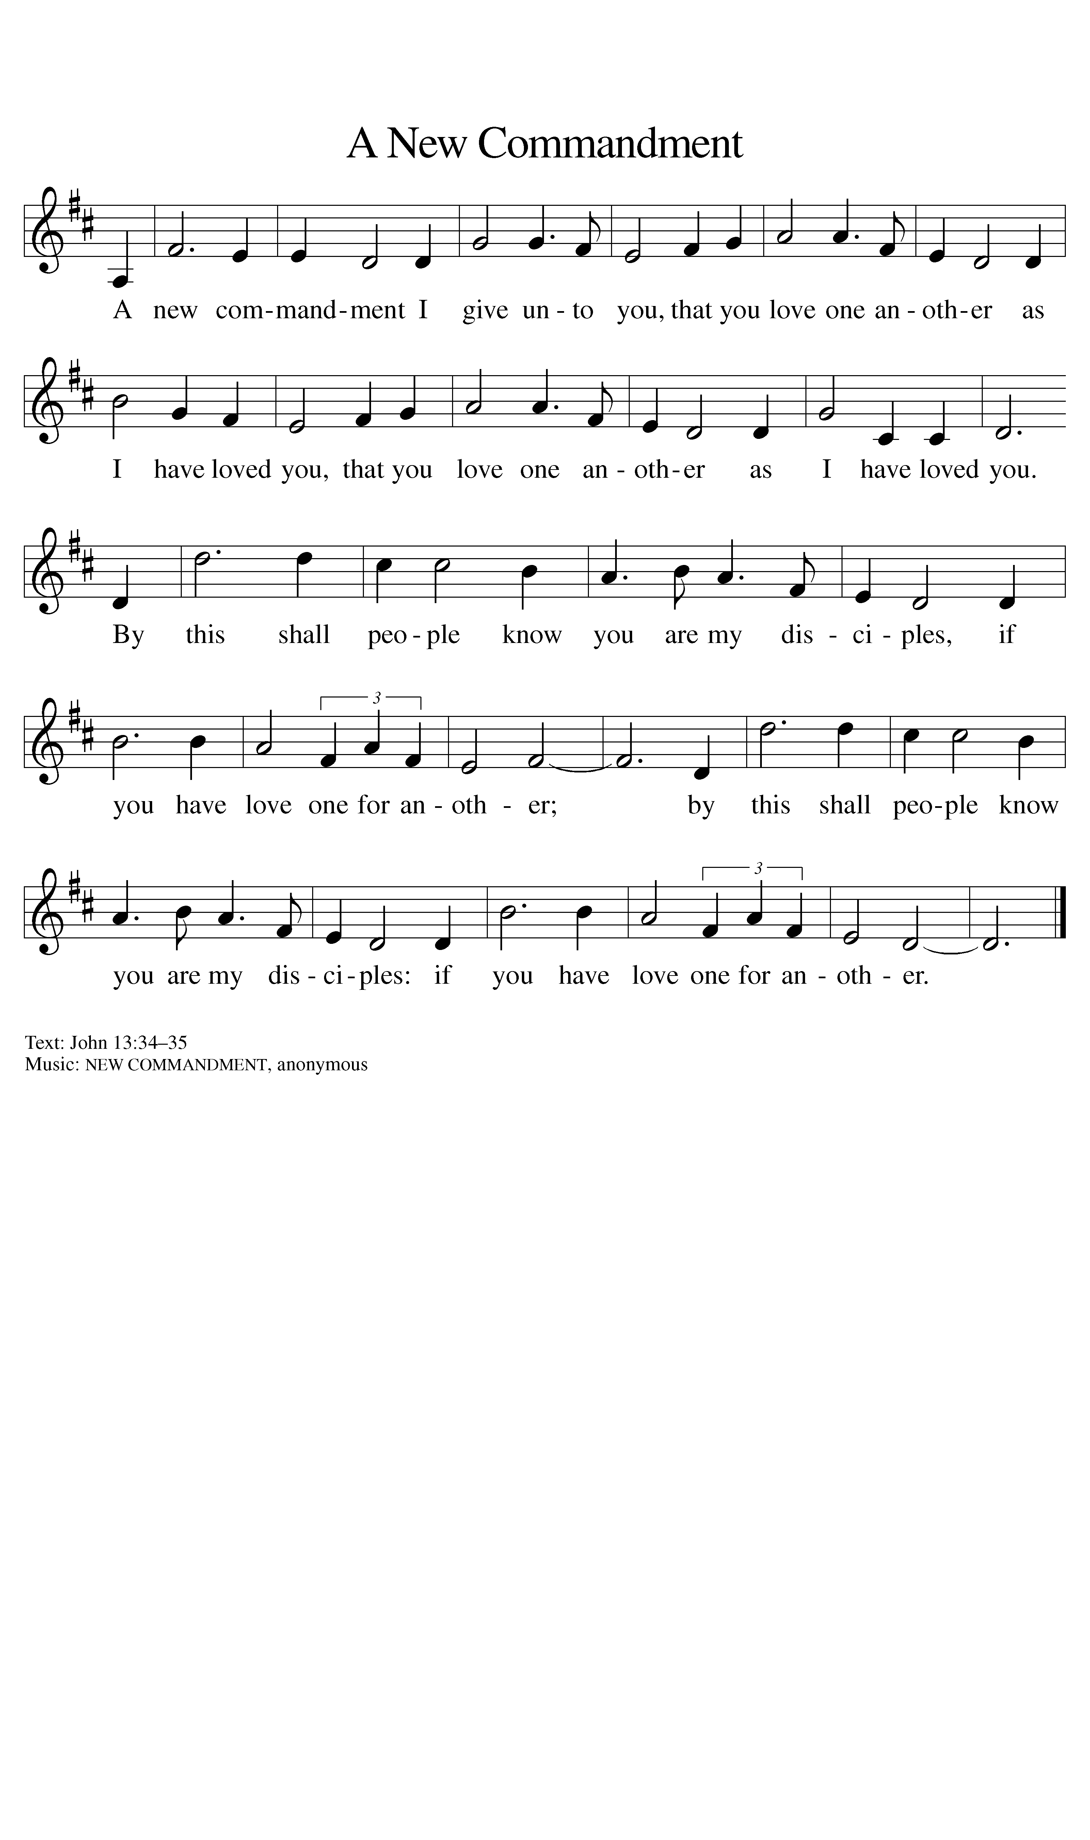
P: Risen One,
you have gathered us around your table of grace
along with these gifts we bring.
Come among us again,
breathe your life into us,
and enliven us with this meal,
that we may live as your risen body in the world. C: Amen

The mEal

Christ is truly present in the bread and the wine. This makes communion one of the places where God’s touch can be most clearly felt. [Grape juice and gluten-free wafers are available upon request.]

P: God of all creation, all you have made is good,
C: and your love endures forever.
P: You bring forth bread from the earth
C: and fruit from the vine.
P: Nourish us with these gifts,
All: that we might be for the world signs of your gracious presence.
C: Amen
P: In the night in which he was betrayed, our Lord Jesus took bread,
and gave thanks; broke it, and gave it to his disciples, saying: Take and eat;
this is my body, given for you. Do this for the remembrance of me.
Again, after supper, he took the cup, gave thanks, and gave it for all to
drink, saying: This cup is the new covenant in my blood, shed for you and
for all people for the forgiveness of sin. Do this for the remembrance of me.

For as often as we eat of this bread and drink from this cup,
we proclaim the Lord’s death until he comes.
C: Christ has died. Christ is risen. Christ will come again

P: Let us pray the prayer that our Lord first gave us.
C: Our Father, who art in heaven, hallowed be thy name,
thy kingdom come, thy will be done,
on earth as it is in heaven.
Give us this day our daily bread;
and forgive us our trespasses,
as we forgive those who trespass against us;
and lead us not into temptation, but deliver us from evil.
For thine is the kingdom,
and the power, and the glory, forever and ever. C: Amen
P: Come for all is ready. (The ushers will call up you up)
Communion Distribution

P: The body and blood of our Lord Jesus Christ strengthen you
and keep you in his grace. C: Amen

P: Living One,
in this feast you have made yourself known to us.
Send us now to tell of your wonders, sing of your glory,
and proclaim your risen life to a wounded and weary world. C: Amen

SENDING

BLESSING (Please Stand)
The triune God,
who was, who is, and who is to come,
Sovereign, ☩ Savior, and Spirit,
light your way with resurrection dawn,
now and always.
C: Amen. [The assembly is seated.]

BRIEF ANNOUNCEMENTS & WEEKLY REFLECTION

Go, My Children, with My Blessing ELW #543
(Please Stand)
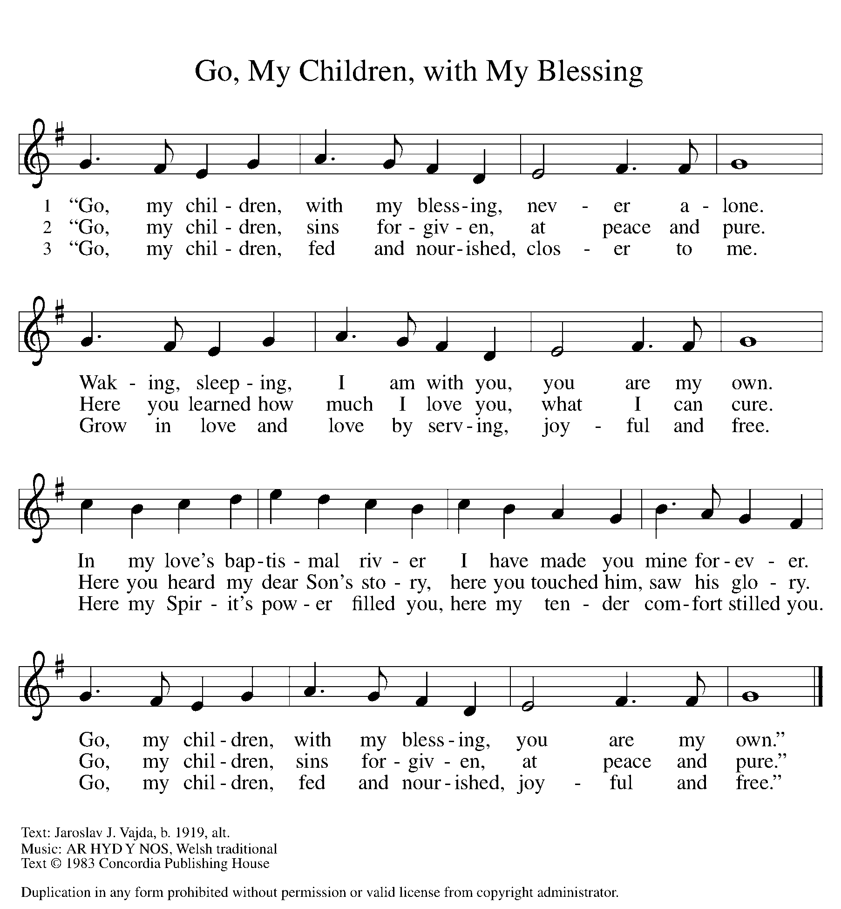

DISMISSAL
P: Alleluia! Christ is risen.
C: Christ is risen indeed. Alleluia!
P: Go in peace. In Christ you are made new. Alleluia! Alleluia!
C: Thanks be to God. Alleluia! Alleluia!
POSTLUDE

