“A community
of ordinary people
celebrating
an extraordinary God;
growing in faith,
serving in love,
proclaiming God’s grace.”

Welcome to Grace Lutheran Church
5/28/23

200 Wabash Avenue
Ukiah, CA 95482
Office (707) 462-7795

Pastor Kristi Gallimore
gracelutheranukiah@gmail.com www.gracelutheranukiah.com

Information for your first time at Grace…

THANK YOU for worshipping with us this day. We hope you experience the presence of God in this place and you are encouraged to further your personal relationship with Jesus Christ. If you’re looking for a community of believers to worship God with, we would like you to consider us your new church home. WELCOME!!

HOLY COMMUNION: is offered to all that hunger for the presence and promises of the risen Christ. We welcome all to the Lord’s Table at our service.

RESTROOMS: are conveniently located in the fellowship hall and in the sanctuary hall.

OUR WORSHIP TODAY

MINISTERS: All Members of the Congregation

WORSHIP LEADER: Pastor Kristi Gallimore

MUSICIAN: Lori Schafer and Galen Gallimore

AUDIO VISUAL: Jack Vinyard, Andrew Gallimore

ASISSTANT/PRAYER: Bill Rus

READER: Anne Barnes

USHER: Bill Yoder & Kristopher Sullivan

CUSTODIAN: Prestino

Gathering

L=Leader A=Assistant R=Reader C=Congregation

Welcome To Grace Lutheran Chruch

CONFESSION AND FORGIVENESS (Please Stand)

P: Let us confess our sin in the presence of God and of one another.
[Silence is kept for reflection.]

P: Most merciful God,
C: we confess that we are captive to sin
and cannot free ourselves.
We have sinned against you in thought, word, and deed,
by what we have done and by what we have left undone.
We have not loved you with our whole heart;
we have not loved our neighbors as ourselves.
For the sake of your Son, Jesus Christ, have mercy on us.
Forgive us, renew us, and lead us, so that we may delight
in your will and walk in your ways,
to the glory of your holy name. C: Amen

P: In the mercy of almighty God,
Jesus Christ was given to die for us, and for his sake
God forgives us all our sins.
As a called and ordained minister
of the church of Christ, and by his authority,
I therefore declare to you the entire forgiveness of all your sins,
in the name of the Father, and of the + Son, and of the Holy Spirit.
C: Amen

Sharing the Peace Of GOD
[Please greet one another with a sign of Christ's peace with a hand gesture or wave.]

P: The grace of our Lord Jesus Christ, the love of God,
and the communion of the Holy Spirit be with you all.
C: And also with you.
P: The peace of the Lord be with you always.
C: And also with you.

Rise Up, O Saints of God ELW #669
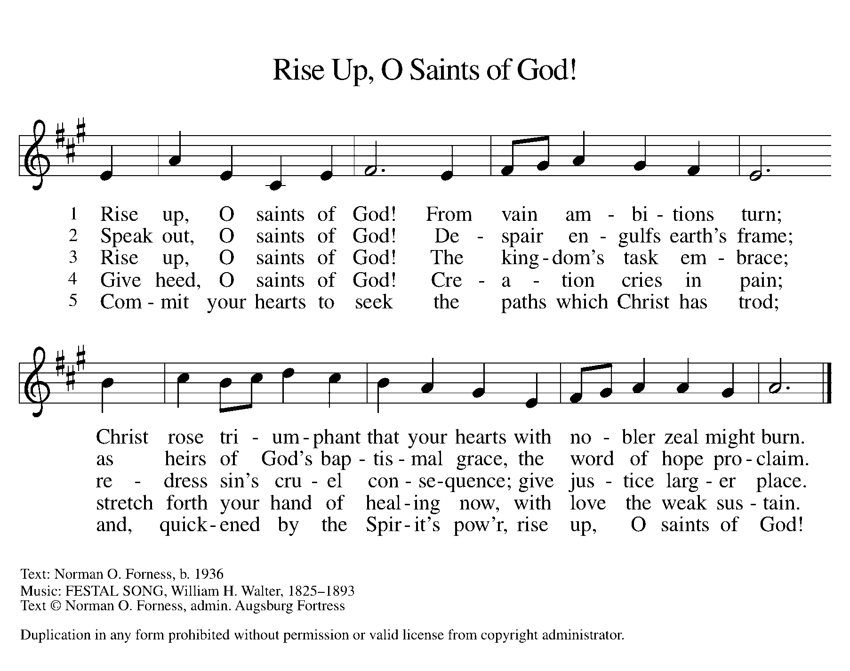

PRAYER OF THE DAY
P: Let us pray together.
C: O God, thank you for sending your spirit.
Direct us by that Spirit so we may have a right judgment in all
things and rejoice at all times in your peace. C: Amen
(The assembly is seated)
The Word of God

First Reading: Pentecost was a Jewish harvest festival that marked the fiftieth day after Passover. Luke portrays the Holy Spirit being poured out upon the disciples before the gathered and astonished people assembled in Jerusalem for the festival. Filled with the Spirit, the disciples were able to witness to the power of Christ’s resurrection.

Acts 2:1-21

¹When the day of Pentecost had come, [the apostles] were all together in one place. ²And suddenly from heaven there came a sound like the rush of a violent wind, and it filled the entire house where they were sitting. ³Divided tongues, as of fire, appeared among them, and a tongue rested on each of them. ⁴All of them were filled with the Holy Spirit and began to speak in other languages, as the Spirit gave them ability.
⁵Now there were devout Jews from every nation under heaven living in Jerusalem. ⁶And at this sound the crowd gathered and was bewildered, because each one heard them speaking in the native language of each. ⁷Amazed and astonished, they asked, “Are not all these who are speaking Galileans? ⁸And how is it that we hear, each of us, in our own native language? ⁹Parthians, Medes, Elamites, and residents of Mesopotamia, Judea and Cappadocia, Pontus and Asia, ¹⁰Phrygia and Pamphylia, Egypt and the parts of Libya belonging to Cyrene, and visitors from Rome, both Jews and proselytes, ¹¹Cretans and Arabs—in our own languages we hear them speaking about God’s deeds of power.” ¹²All were amazed and perplexed, saying to one another, “What does this mean?” ¹³But others sneered and said, “They are filled with new wine.”
¹⁴But Peter, standing with the eleven, raised his voice and addressed them, “Men of Judea and all who live in Jerusalem, let this be known to you, and listen to what I say. ¹⁵Indeed, these are not drunk, as you suppose, for it is only nine o’clock in the morning. ¹⁶No, this is what was spoken through the prophet Joel:
¹⁷‘In the last days it will be, God declares,
that I will pour out my Spirit upon all flesh,
and your sons and your daughters shall prophesy,
and your young men shall see visions,
and your old men shall dream dreams.
¹⁸Even upon my slaves, both men and women,
in those days I will pour out my Spirit;
and they shall prophesy.
¹⁹And I will show portents in the heaven above
and signs on the earth below,
blood, and fire, and smoky mist.
²⁰The sun shall be turned to darkness
and the moon to blood,
before the coming of the Lord’s great and glorious day.
²¹Then everyone who calls on the name of the Lord shall be saved.’ ”

R: The word of the Lord C: Thanks be to God

Second Reading: Paul is helping the Corinthians understand the relationship between our God-given unity and Spirit-created diversity. The Spirit creates the unity of faith and gives all Christians diverse gifts for the common benefit of all. We need one another’s diverse spiritual gifts because the same Spirit has given them to each person for the common good.
1 Corinthians 12:3b-13
^{3b}No one can say “Jesus is Lord” except by the Holy Spirit.
⁴Now there are varieties of gifts, but the same Spirit; ⁵and there are varieties of services, but the same Lord; ⁶and there are varieties of activities, but it is the same God who activates all of them in everyone. ⁷To each is given the manifestation of the Spirit for the common good. ⁸To one is given through the Spirit the utterance of wisdom, and to another the utterance of knowledge according to the same Spirit, ⁹to another faith by the same Spirit, to another gifts of healing by the one Spirit, ¹⁰to another the working of miracles, to another prophecy, to another the discernment of spirits, to another various kinds of tongues, to another the interpretation of tongues. ¹¹All these are activated by one and the same Spirit, who allots to each one individually just as the Spirit chooses.
¹²For just as the body is one and has many members, and all the members of the body, though many, are one body, so it is with Christ. ¹³For in the one Spirit we were all baptized into one body—Jews or Greeks, slaves or free—and we were all made to drink of one Spirit.
R: The word of the Lord C: Thanks be to God

Children’s Message

(Please Stand)

Gospel Reading: The risen Jesus appears to his disciples, offering

them a benediction, a commission, and the gift of the Holy Spirit.

John 20:19-23
¹⁹When it was evening on that day, the first day of the week, and the doors of the house where the disciples had met were locked for fear of the Jews, Jesus came and stood among them and said, “Peace be with you.” ²⁰After he said this, he showed them his hands and his side. Then the disciples rejoiced when they saw the Lord. ²¹Jesus said to them again, “Peace be with you. As the Father has sent me, so I send you.” ²²When he had said this, he breathed on them and said to them, “Receive the Holy Spirit. ²³If you forgive the sins of any, they are forgiven them; if you retain the sins of any, they are retained.”
R: The Gospel of the Lord C: Thanks be to God

(Please be seated)
Sermon
Pastor Kristi Gallimore

God of Tempest, God of Whirlwind ELW #400
(Please Stand)
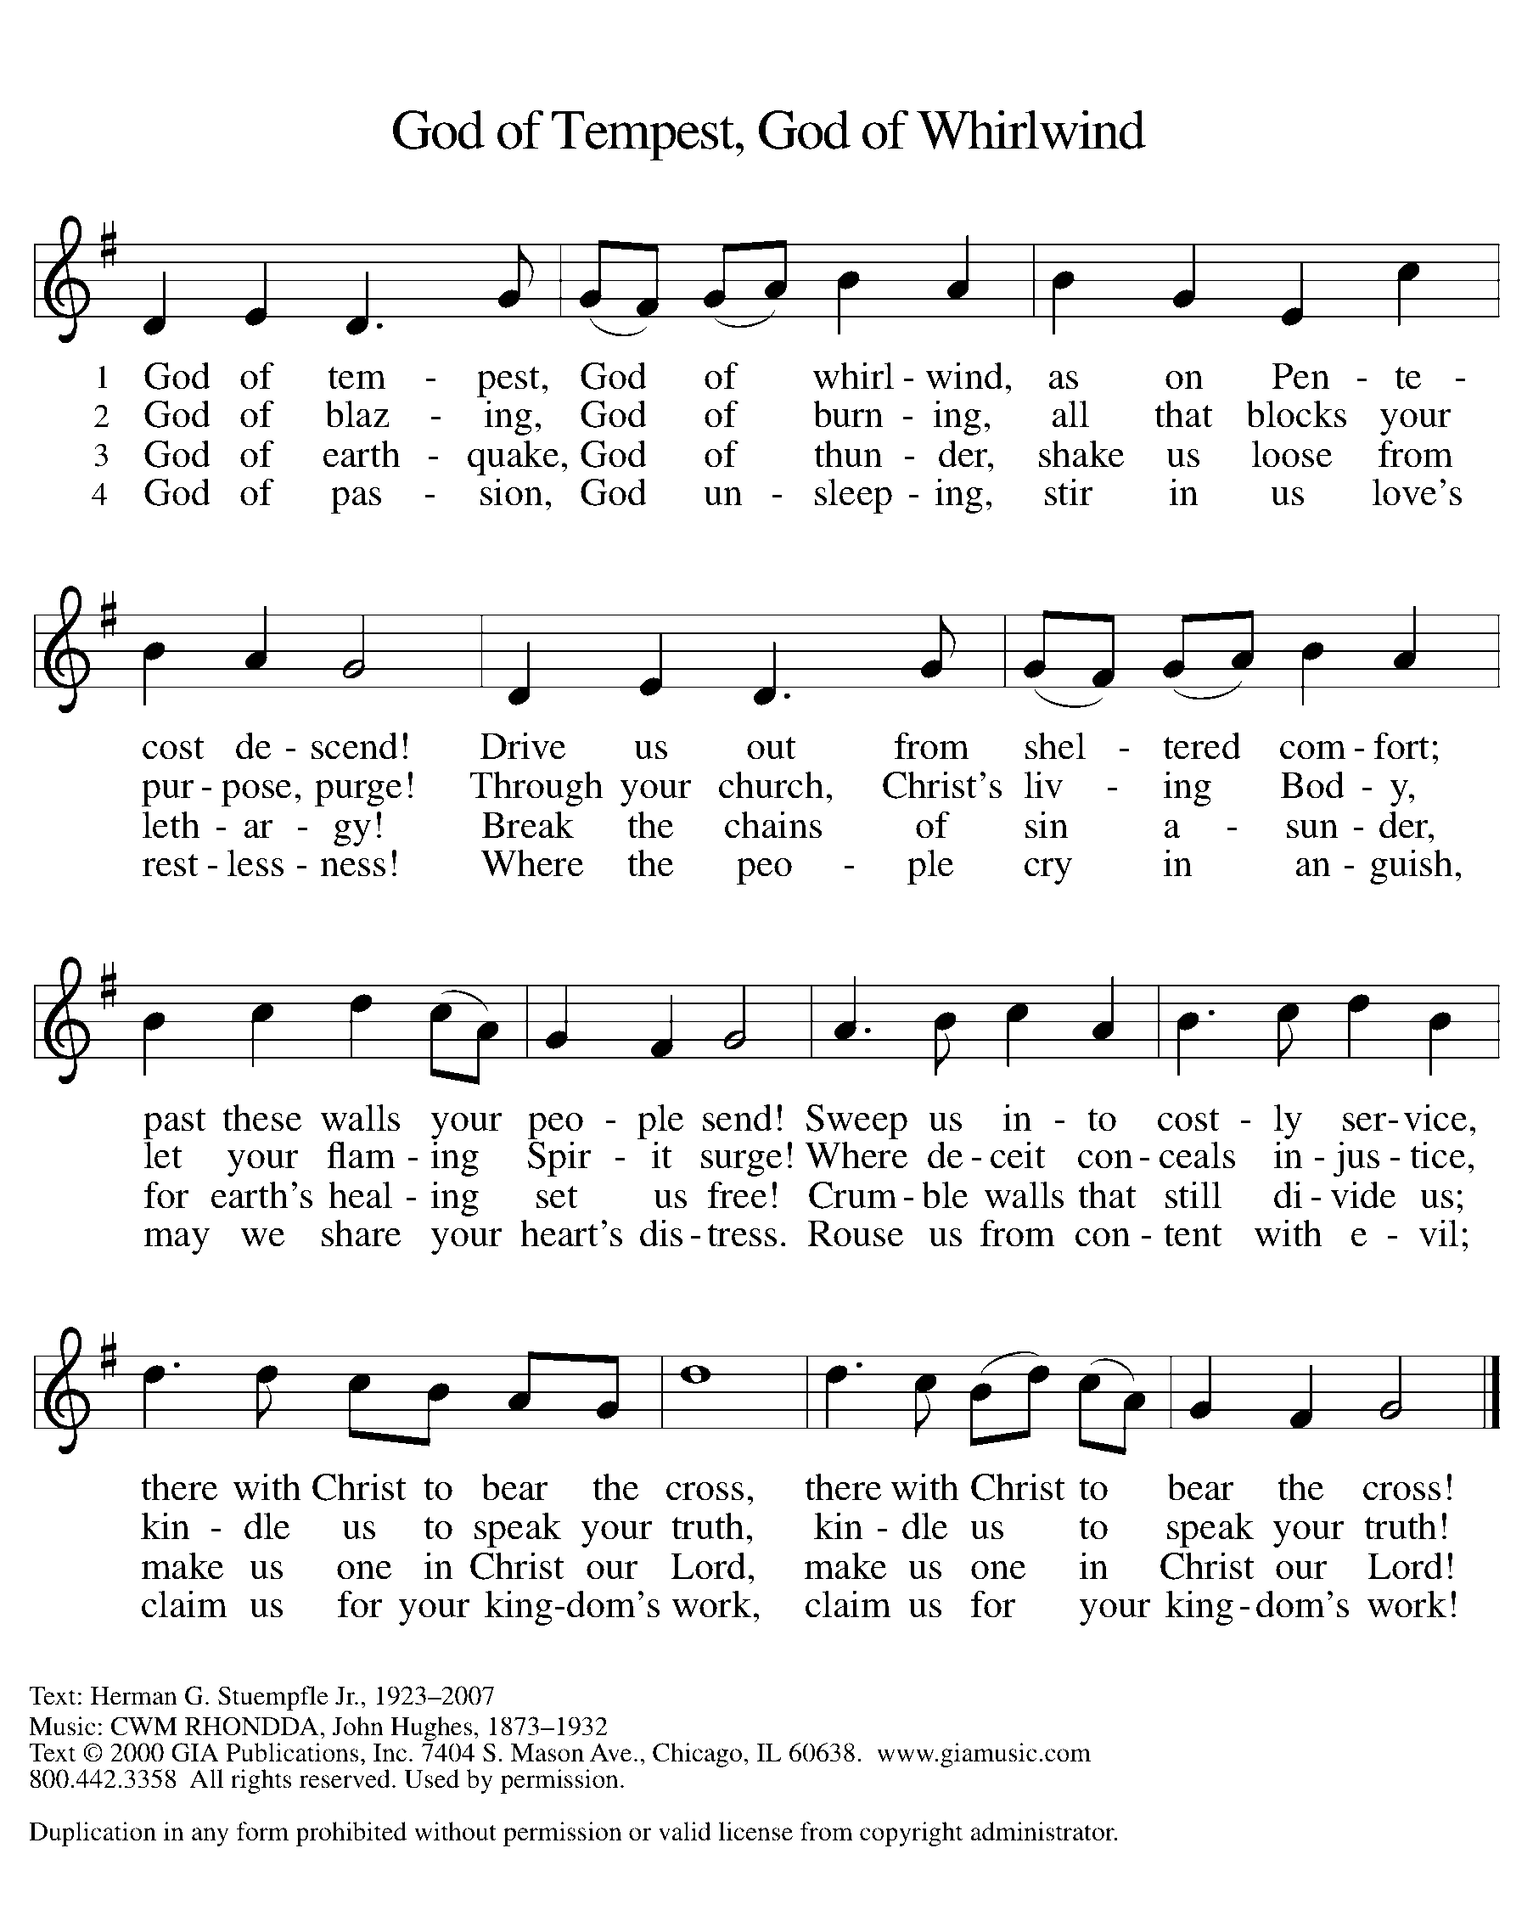

CREED
P: Let us confess our faith using the words of the Apostles’ Creed

C: I believe in God, the Father almighty,
creator of heaven and earth.
I believe in Jesus Christ, his only Son, our Lord.
He was conceived by the power of the Holy Spirit
and born of the virgin Mary.
He suffered under Pontius Pilate,
was crucified, died, and was buried. He descended into hell.

On the third day he rose again. He ascended into heaven,
and is seated at the right hand of the Father.
He will come again to judge the living and the dead.
I believe in the Holy Spirit,
the holy catholic church, the communion of saints,
the forgiveness of sins, the resurrection of the body,
and the life everlasting. C: Amen

PRayers of the people
A: United in the hope and joy of the resurrection, let us pray for the
church, the world, and all in need.
A: Lord, in your mercy
C: hear our prayer [The prayers are concluded…]

A: Rejoicing in the victory of Christ’s resurrection, we lift our prayers
and praise to you, almighty and eternal God. C: Amen (Please be seated)
OFFERING
We offer our gifts of time, talent, food and finances to God to return to God all the
blessings He has first given us. Please put your offering in the plate as it is passed.

Spirit of the Living God TFF #101
(Please Stand)

P: Generous God, (Please Stand)
in this meal you offer your very self.
We give thanks for these gifts of the earth.
In the breaking of this bread
reveal to us the Risen One.
In the pouring of this wine
pour us out in service to the world;
through Christ our Lord. C: Amen

The mEal

Christ is truly present in the bread and the wine. This makes communion one of the places where God’s touch can be most clearly felt. [Grape juice and gluten-free wafers are available upon request.]

P: God of all creation, all you have made is good,
C: and your love endures forever.
P: You bring forth bread from the earth
C: and fruit from the vine.
P: Nourish us with these gifts,
All: that we might be for the world signs of your gracious presence.
C: Amen

P: In the night in which he was betrayed, our Lord Jesus took bread, and gave thanks; broke it, and gave it to his disciples, saying: Take and eat; this is my body, given for you. Do this for the remembrance of me.
Again, after supper, he took the cup, gave thanks, and gave it for all to drink, saying: This cup is the new covenant in my blood, shed for you and for all people for the forgiveness of sin.

Do this for the remembrance of me. For as often as we eat of this bread and drink from this cup, we proclaim the Lord’s death until he comes.
C: Christ has died. Christ is risen. Christ will come again
P: Let us pray the prayer that our Lord first gave us.
C: Our Father, who art in heaven, hallowed be thy name,
thy kingdom come, thy will be done,
on earth as it is in heaven.
Give us this day our daily bread;
and forgive us our trespasses,
as we forgive those who trespass against us;
and lead us not into temptation, but deliver us from evil.
For thine is the kingdom,
and the power, and the glory, forever and ever. C: Amen
(The assembly is seated)
Communion Distribution
P: The body and blood of our Lord Jesus Christ strengthen you
and keep you in his grace. C: Amen

P: Gracious God,
in you we live and move and have our being.
With your word and this meal of grace,
you have nourished our life together.
Strengthen us to show your love
and serve the world in Jesus’ name. C: Amen

SENDING

BLESSING (Please Stand)
P: The God of all,
who raised ☩ Jesus from the dead,
bless you by the power of the Holy Spirit
to live in the new creation.
C: Amen. [The assembly is seated.]

BRIEF ANNOUNCEMENTS
& WEEKLY REFLECTION

Spirit of Gentleness ELW # 396
(Please Stand)
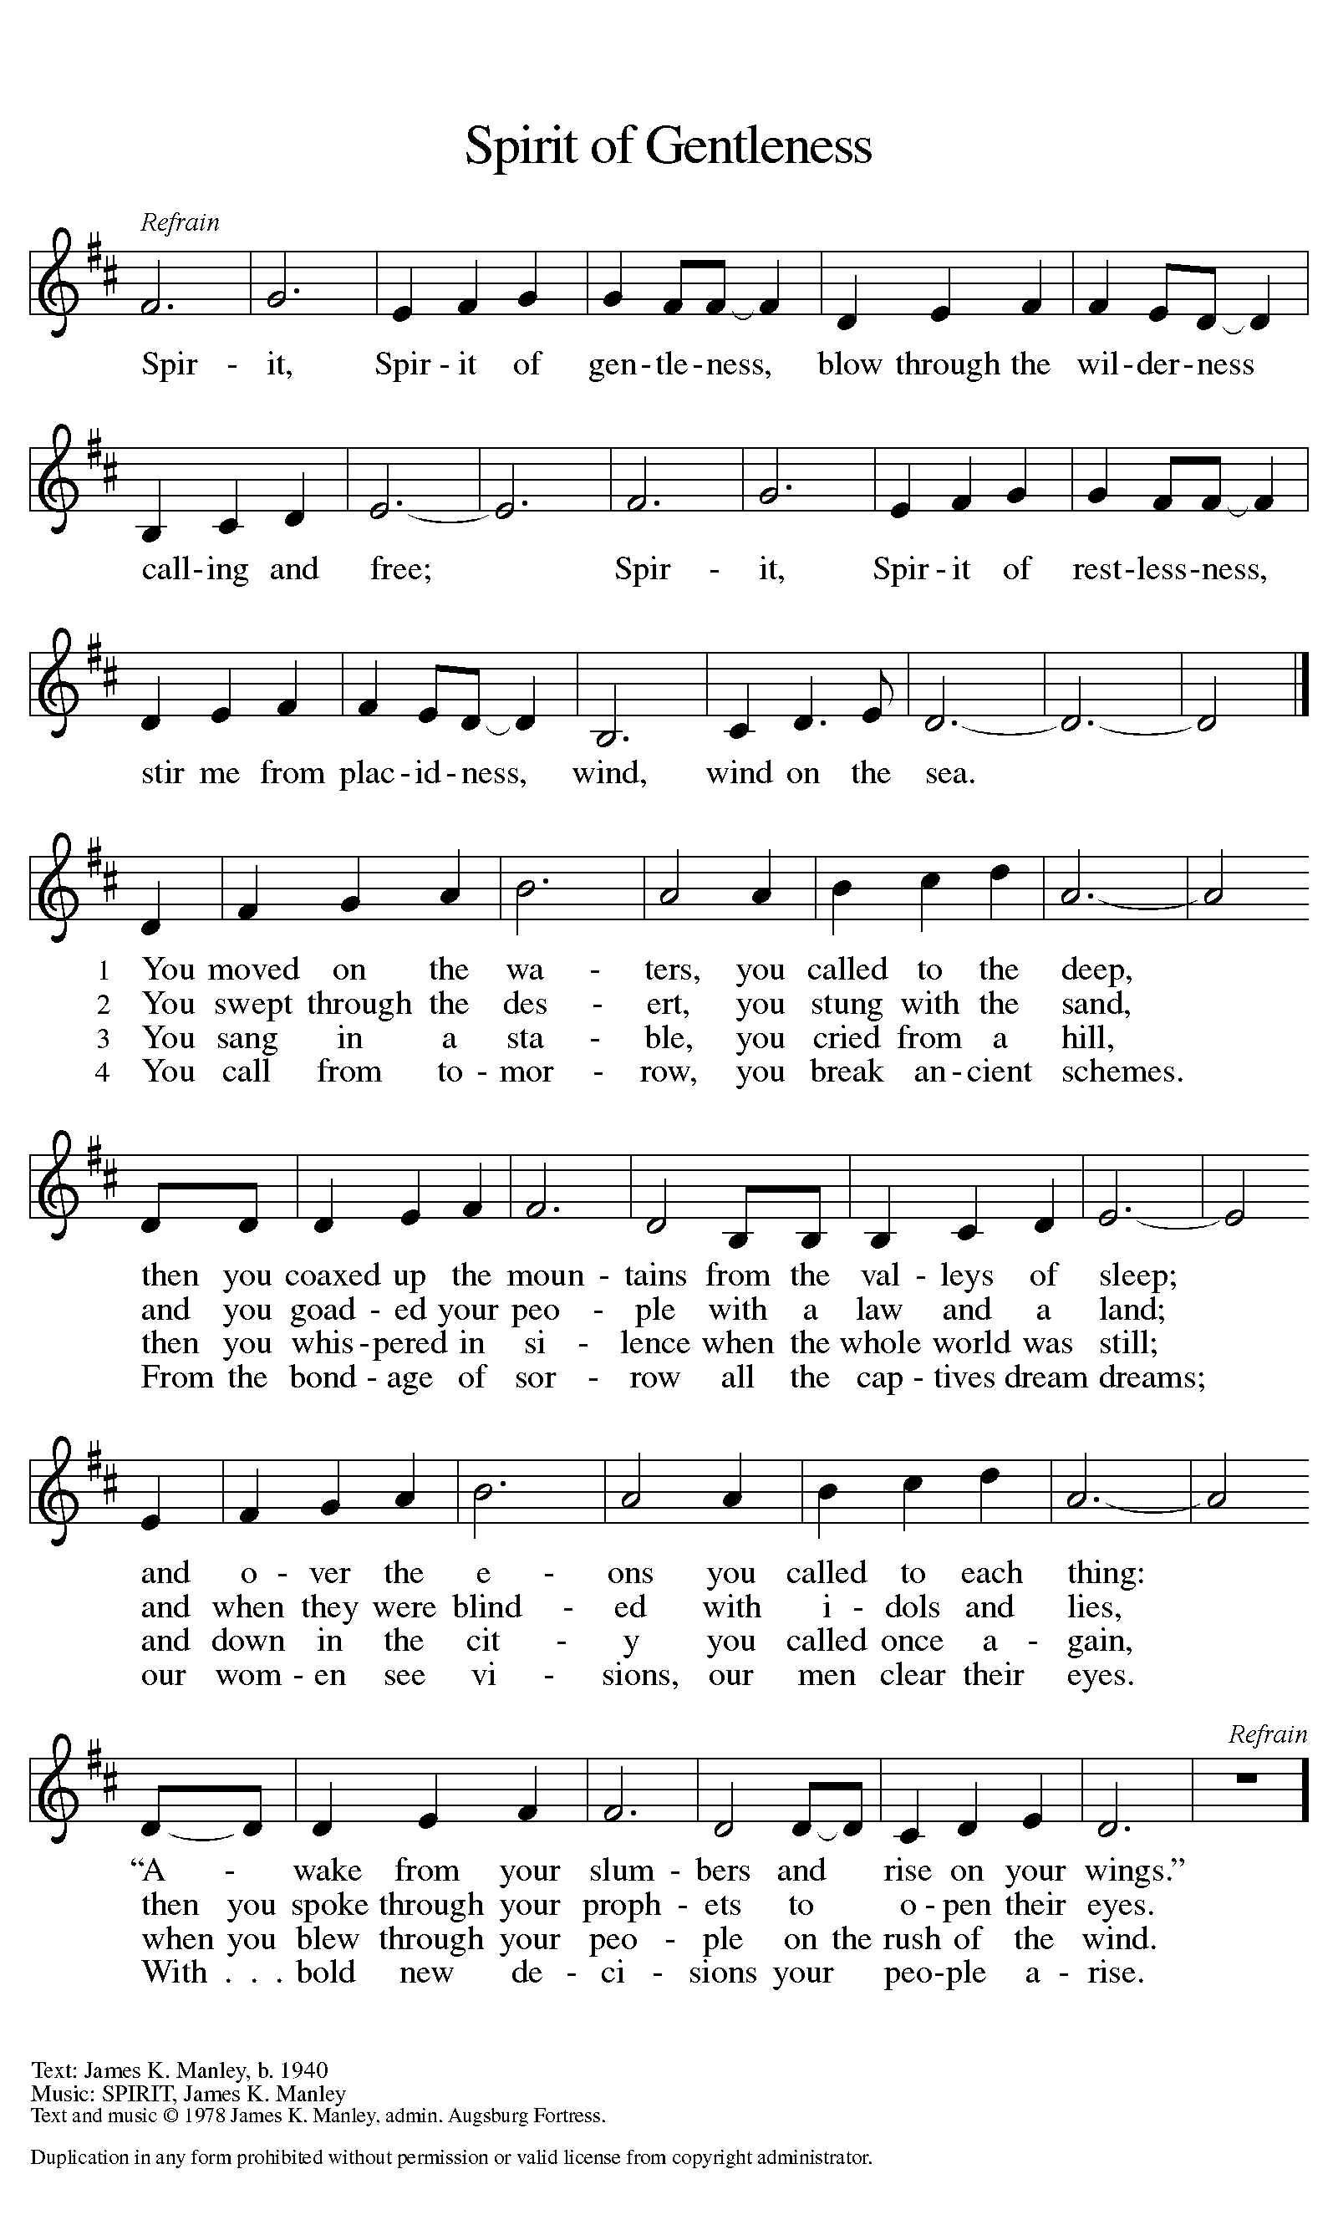

DISMISSAL
P: Go in peace. Serve the Risen One.
C: Thanks be to God.
POSTLUDE

