Welcome to
Grace Lutheran Church
8/17/25



growing in faith,
serving in love,
proclaiming God’s grace!

200 Wabash Avenue Ukiah, CA 95482
Office (707) 462-7795 gracelutheranukiah@gmail.com
www.gracelutheranukiah.com

Pastor Kristi Gallimore

Information for your first time at Grace…

THANK YOU for worshipping with us this day. We hope you experience the presence of God in this place and you are encouraged to further your personal relationship with Jesus Christ. If you’re looking for a community of believers to worship God with, we would like you to consider us your new church home. WELCOME!!

HOLY COMMUNION: is offered to all that hunger for the presence and promises of the risen Christ. We welcome all to the Lord’s Table at our service.

RESTROOMS: are conveniently located in the fellowship hall and in the sanctuary hall.

OUR WORSHIP TODAY

MINISTERS: All Members of the Congregation

WORSHIP LEADER: Pastor Kristi Gallimore

MUSICIAN: Lori Schafer and Galen Gallimore

AUDIO VISUAL: Jack Vinyard, Nathaniel Gallimore,
Kristopher Sullivan, Layla Mason

ASISSTANT/PRAYER:

READER: Bill Rus

USHER: Bill Dabbs & Bill Yoder

CUSTODIAN: Steliga

Gathering

L=Leader A=Assistant R=Reader C=Congregation

Welcome To Grace Lutheran Chruch
CONFESSION AND FORGIVENESS (Please Stand)

P: Let us confess our sin in the presence of God and of one another.
[Silence is kept for reflection.]

C: Merciful God,
you free us to love others,
but we neglect our neighbors and follow our own way.
You lead us by the Spirit of joy and peace,
but we turn away from the abundant life you offer.
You surround us with patience, kindness,
and generosity,
but we grow weary in doing what is right.
In your mercy, forgive us.
Do not give up on us.
Heal us, break our bonds,
and show us the path of life. C: Amen.

P: You belong to Christ Jesus
and you are God’s children through faith.
In the cross of ☩ Christ,
and through the power of the Holy Spirit,
your sins are forgiven.
Clothed with Christ, you are a new creation. All: Amen.

Sharing the Peace Of GOD
[Please greet one another with a sign of Christ's peace with a hand gesture or wave.]

P: The grace of our Lord Jesus Christ, the love of God,
and the communion of the Holy Spirit be with you all.
C: And also with you.
P: The peace of the Lord be with you always.
C: And also with you.

How Firm a Foundation ELW #796
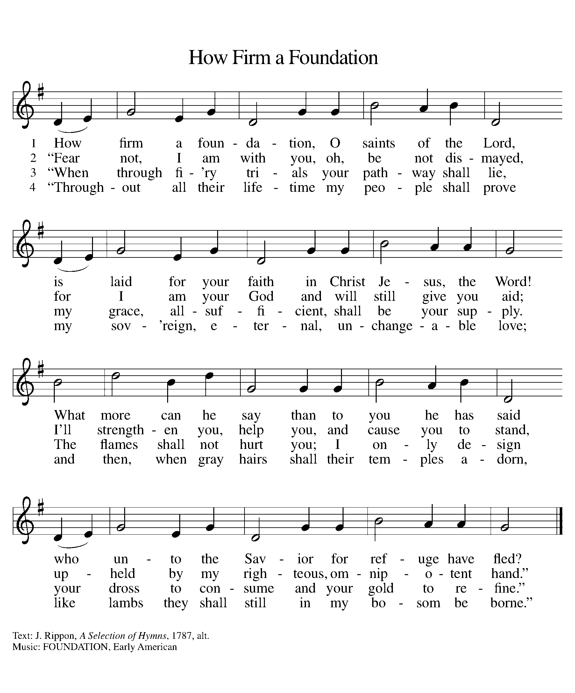

PRAYER OF THE DAY
P: Let us pray together.
C: O God, you love justice and hate oppression, and you call us to
share your truth. Give us courage to take our stand with all victims
of bloodshed and greed, as the prophets and Jesus did before us.
C: Amen
(The assembly is seated)
The Word of God

First Reading: Because Jeremiah preaches the unpopular message of

God’s judgment, he suffers rejection. Today’s reading distinguishes between

the true prophet, like Jeremiah, who speaks God’s word, and the false

prophet who misleads the people through dreams. One is like wheat;

the other like worthless straw.

Jeremiah 23:23-29
²³ Am I a God near by, says the Lord, and not a God far off? ²⁴ Who can hide in secret places so that I cannot see them? says the Lord. Do I not fill heaven and earth? says the Lord. ²⁵ I have heard what the prophets have said who prophesy lies in my name, saying, “I have dreamed! I have dreamed!” ²⁶ How long? Will the hearts of the prophets ever turn back—those who prophesy lies and who prophesy the deceit of their own heart? ²⁷ They plan to make my people forget my name by their dreams that they tell one another, just as their ancestors forgot my name for Baal. ²⁸ Let the prophet who has a dream tell the dream, but let the one who has my word speak my word faithfully. What has straw in common with wheat? says the Lord. ²⁹ Is not my word like fire, says the Lord, and like a hammer that breaks a rock in pieces?

R: The word of the Lord C: Thanks be to God

Second Reading: The author of Hebrews presents us with rich stories of faith. In a long list of biblical heroes, we find examples of trust in God that enabled them to face the trials of life faithfully. In addition to this “cloud of witnesses,” we have Jesus, the perfect model of faithful endurance.

Hebrews 11:29-12:2
²⁹ By faith the people passed through the Red Sea as if it were dry land, but when the Egyptians attempted to do so they were drowned. ³⁰ By faith the walls of Jericho fell after they had been encircled for seven days. ³¹ By faith Rahab the prostitute did not perish with those who were disobedient, because she had received the spies in peace.
³² And what more should I say? For time would fail me to tell of Gideon, Barak, Samson, Jephthah, of David and Samuel and the prophets, ³³ who through faith conquered kingdoms, administered justice, obtained promises, shut the mouths of lions, ³⁴ quenched the power of fire, escaped the edge of the sword, were made strong out of weakness, became mighty in war, put foreign armies to flight. ³⁵ Women received their dead by resurrection. Others were tortured, refusing to accept release, in order to obtain a better resurrection. ³⁶ Others suffered mocking and flogging and even chains and imprisonment.
³⁷ They were stoned to death; they were sawn in two; they were killed by the sword; they went about in skins of sheep and goats, destitute, persecuted, tormented ³⁸ of whom the world was not worthy. They wandered in deserts and mountains and in caves and holes in the ground.
³⁹ Yet all these, though they were commended for their faith, did not receive what was promised, ⁴⁰ since God had provided something better so that they would not, apart from us, be made perfect.
^{12:1} Therefore, since we are surrounded by so great a cloud of witnesses, let us also lay aside every weight and the sin that clings so closely, and let us run with perseverance the race that is set before us, ² looking to Jesus, the pioneer and perfecter of faith, who for the sake of the joy that was set before him endured the cross, disregarding its shame, and has taken his seat at the right hand of the throne of God.
R: The word of the Lord C: Thanks be to God

Children’s Message
(Please Stand)
Gospel Reading: Jesus delivers harsh words about the purifying and potentially divisive effects of obedience to God’s call. The way of the cross often leads followers to encounter hostility and rejection, even from those they love.
Luke 12:49-56
[Jesus said:] ⁴⁹ “I have come to cast fire upon the earth, and how I wish it were already ablaze! ⁵⁰ I have a baptism with which to be baptized, and what constraint I am under until it is completed! ⁵¹ Do you think that I have come to bring peace to the earth? No, I tell you, but rather division! ⁵² From now on five in one household will be divided, three against two and two against three; ⁵³ they will be divided:
father against son
and son against father,
mother against daughter
and daughter against mother,
mother-in-law against her daughter-in-law
and daughter-in-law against mother-in-law.”
⁵⁴ He also said to the crowds, “When you see a cloud rising in the west, you immediately say, ‘It is going to rain,’ and so it happens. ⁵⁵ And when you see the south wind blowing, you say, ‘There will be scorching heat,’ and it happens. ⁵⁶ You hypocrites! You know how to interpret the appearance of earth and sky, but why do you not know how to interpret the present time?
R: The Gospel of the Lord C: Thanks be to God
(Please be seated)
Sermon
Pastor Kristi Gallimore
(Please Stan
When Pain of the World Surrounds Us ELW 704
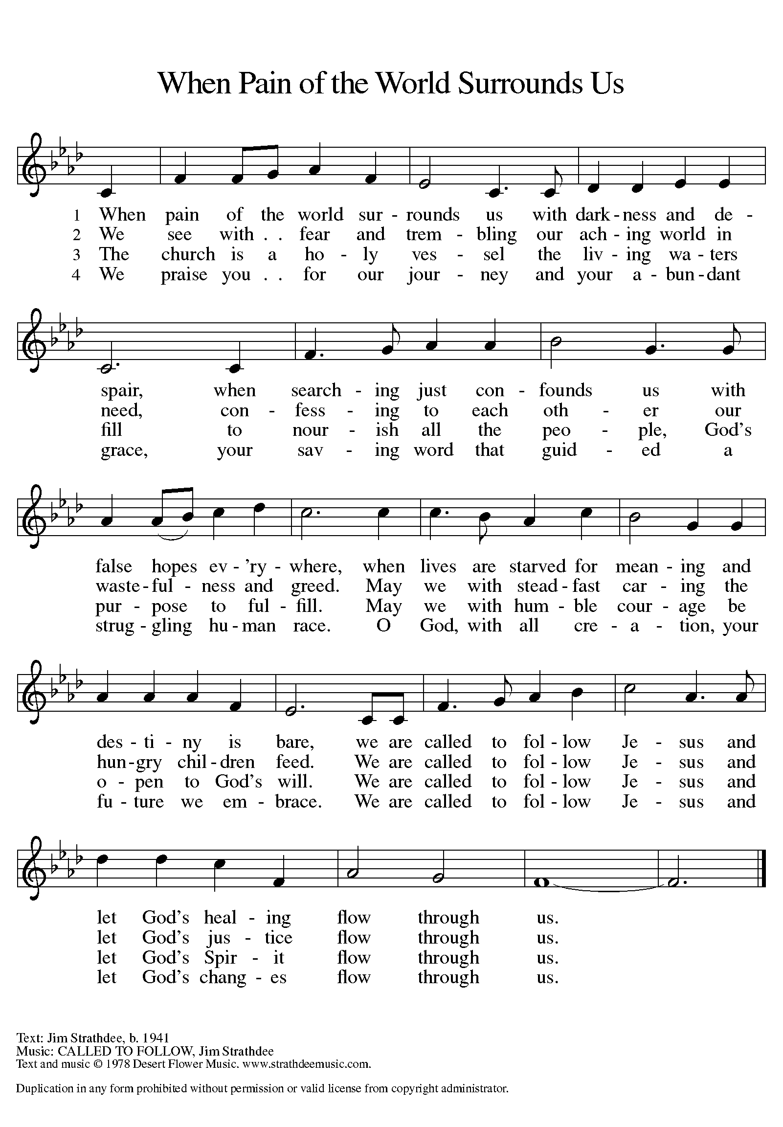

CREED
(A brief statement of the core beliefs of the Christian Church)

P: Let us confess our faith using the words of the Apostles’ Creed

C: I believe in God, the Father almighty,
creator of heaven and earth.
I believe in Jesus Christ, his only Son, our Lord.
He was conceived by the power of the Holy Spirit
and born of the virgin Mary.
He suffered under Pontius Pilate,
was crucified, died, and was buried. He descended into hell.

On the third day he rose again. He ascended into heaven,
and is seated at the right hand of the Father.
He will come again to judge the living and the dead.
I believe in the Holy Spirit,
the holy catholic church, the communion of saints,
the forgiveness of sins, the resurrection of the body,
and the life everlasting. C: Amen

PRayers of the people
A: Let us pray for the church, the creation, and the whole people of God,
for God is near.
A: Lord, in your mercy
C: hear our prayer [The prayers are concluded…]

A: Confident in God’s presence and promise, we entrust our prayers to
the one who always receives them. C: Amen
(Please be seated)
OFFERING
We offer our gifts of time, talent, food and finances to God to return to God all the
blessings He has first given us. Please put your offering in the plate as it is passed.

Refiners Fire

CCLI Song # 426298
Brian Doerksen
© 1990 Mercy / Vineyard Publishing; Vineyard Songs Canada

P: Creator God,
in your wisdom you bring forth all that is good
and the harvest is plentiful.
Strengthen us at your table with these gifts of the earth
and our labor,
that we may work for the good of all. C: Amen
The mEal

Christ is truly present in the bread and the wine. This makes communion one of the places where God’s touch can be most clearly felt. [Grape juice and gluten-free wafers are available upon request.]

P: God of all creation, all you have made is good,
C: and your love endures forever.
P: You bring forth bread from the earth
C: and fruit from the vine.
P: Nourish us with these gifts,
All: that we might be for the world signs of your gracious presence.
C: Amen
P: In the night in which he was betrayed, our Lord Jesus took bread,
and gave thanks; broke it, and gave it to his disciples, saying: Take and eat;
this is my body, given for you. Do this for the remembrance of me.
Again, after supper, he took the cup, gave thanks, and gave it for all to
drink, saying: This cup is the new covenant in my blood, shed for you and
for all people for the forgiveness of sin. Do this for the remembrance of me.

For as often as we eat of this bread and drink from this cup,
we proclaim the Lord’s death until he comes.
C: Christ has died. Christ is risen. Christ will come again

P: Let us pray the prayer that our Lord first gave us.
C: Our Father, who art in heaven, hallowed be thy name,
thy kingdom come, thy will be done,
on earth as it is in heaven.
Give us this day our daily bread;
and forgive us our trespasses,
as we forgive those who trespass against us;
and lead us not into temptation, but deliver us from evil.
For thine is the kingdom,
and the power, and the glory, forever and ever. C: Amen
P: Come for all is ready. (The ushers will call up you up)
Communion Distribution

P: The body and blood of our Lord Jesus Christ strengthen you
and keep you in his grace. C: Amen

P: Mothering God,
you gathered us to your table and we drank deeply of your grace.
Send us out by your Spirit to love our neighbors as ourselves
and proclaim your love in Jesus’ name. C: Amen

SENDING

BLESSING (Please Stand)
The love of God abound in you;
the grace of our Savior Jesus Christ fill your hearts;
and the life of the Spirit
☩ bless you and give you peace.
C: Amen. [The assembly is seated.]

BRIEF ANNOUNCEMENTS & WEEKLY REFLECTION

God Be with You To We Meet Again ELW # 536
(Please Stand)
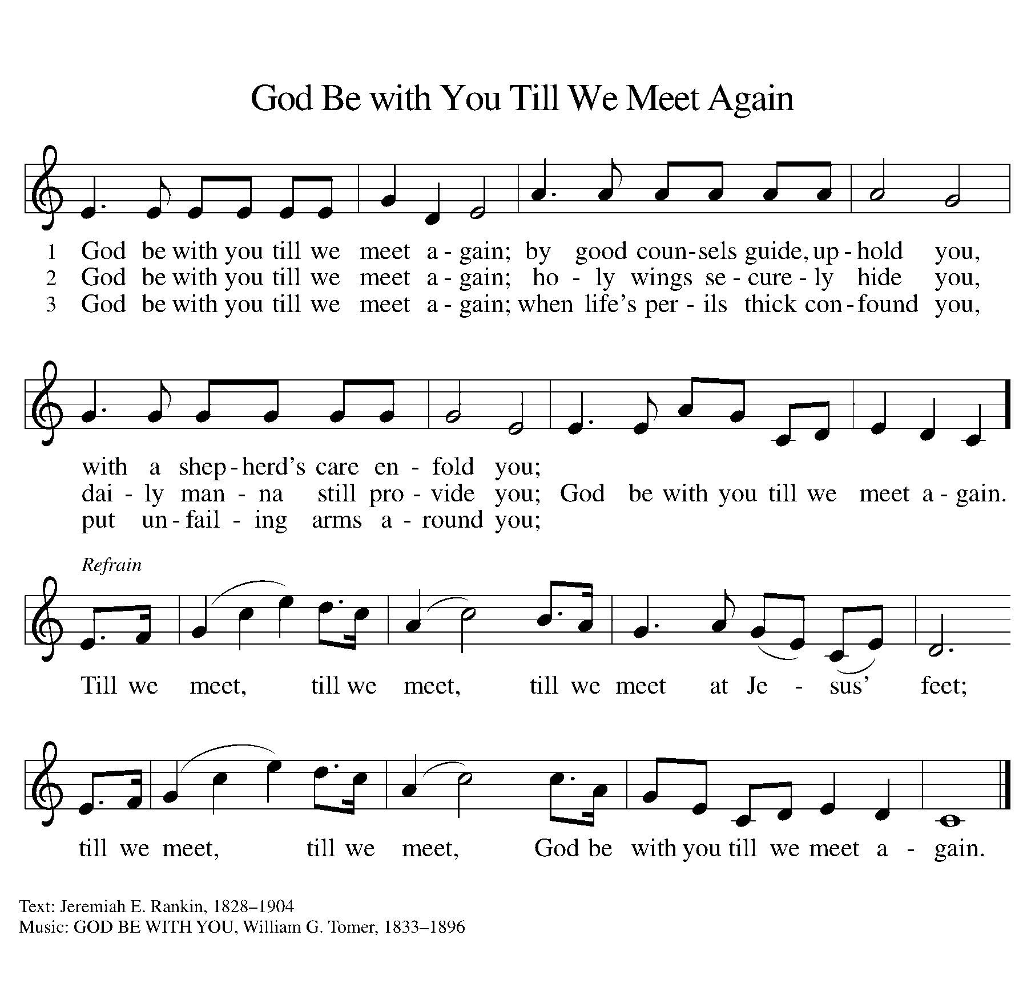

DISMISSAL
P: Go in peace. Live by the Spirit.
C: Thanks be to God.
POSTLUDE

